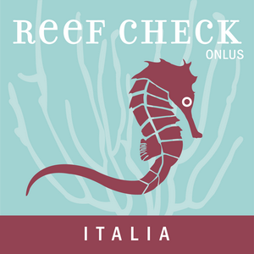

Training on
MPA Management PlanMarch 15-21, 2015
S. Margherita Ligure, Genoa, Italy

First name (*) Other names Family name (*)
Nationality (*) Date of birth (*) Place of birth (*)
Contacts: E-mail (*) Phone Skype
Education level (*): Bc - MSc - PhD in (*)
Current occupation employer
Short motivational statement (* a maximum of 3 rows are required):

Please include a short CV, in English.

The participation fee is 600 Euro, covering only teaching costs.

Signed virtually through the submission of the form

(*) Mandatory field

To register, kindly complete the form above and send it as a pdf by email to postmaster@reefcheckitalia.it. Registration will be finalised upon receipt of the registration fee. You will receive a confirmation of your registration via e-mail. We recommend you to print the e-mail and keep it as a record of your registration. Cancellations of registration must be received - in writing - no later than 10 March 2015. Refunds for registration fees will be subject to a 20% handling fee and will be processed after the event. No refund will be made for cancellations received after 10 March 2015 or for 'no shows'. After 10 March 2015 no refunds will be made for professional or personal emergencies, flight cancellations, denied visa, weather related cancellation or other travel emergencies.

All dates should be in the format dd/MM/yyyy.

